**Project Development Phase**

**Model Performance Test**

|  |  |
| --- | --- |
| Date | 10 November 2022 |
| Team ID | PNT2022TMID23159 |
| Project Name | Project -Predicting the energy output of wind turbine based on weather condition |
| Maximum Marks | 10 Marks |

**Model Performance Testing:**

Project team shall fill the following information in model performance testing template.

**Parameter**

**REGRESSION MODEL:**

In this model we get,

Squarederror - 0.9222746826171284

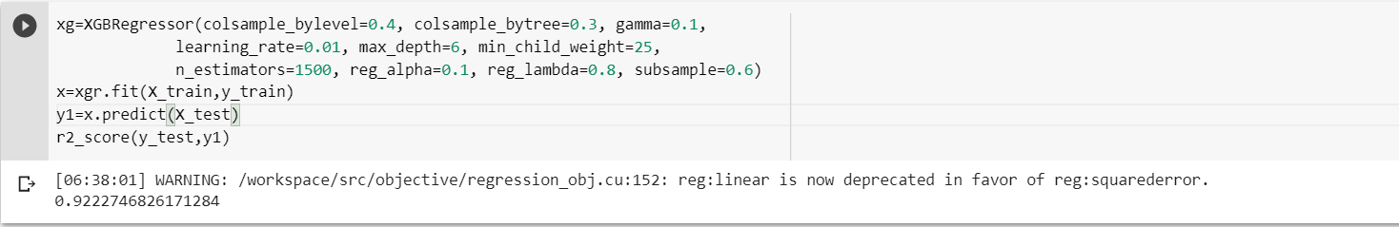

Mean squared error

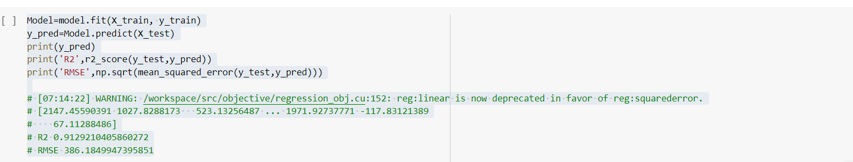

**CLASSIFICATION MODEL :**

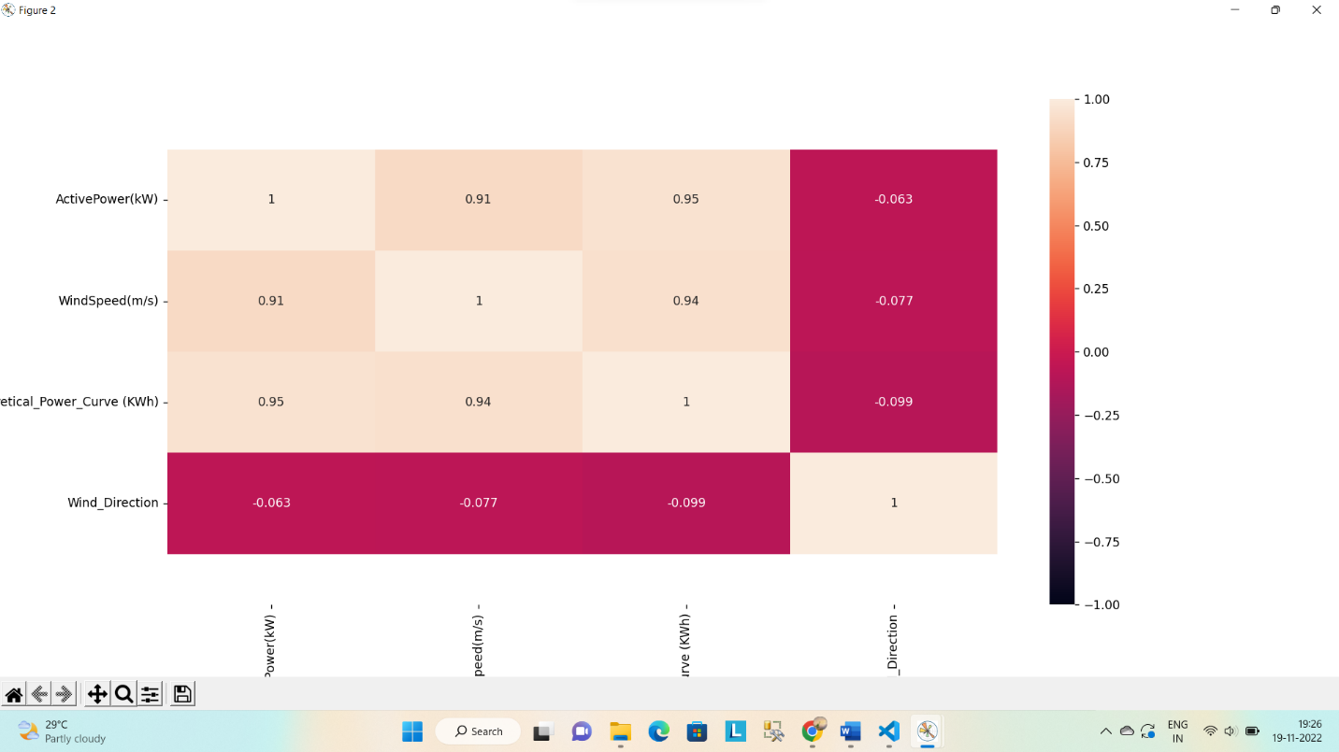

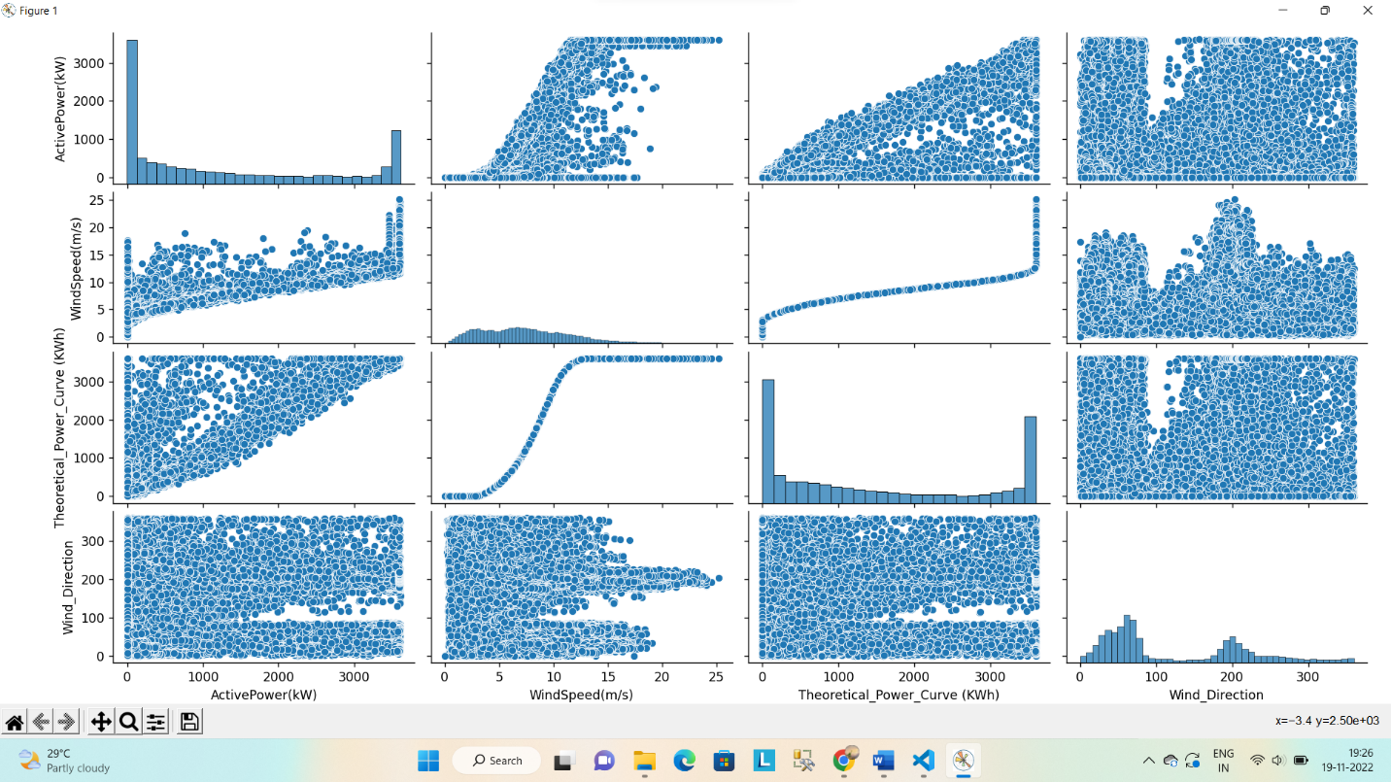

**TUNE THE MODEL:**

**Hyper parameter tuning**



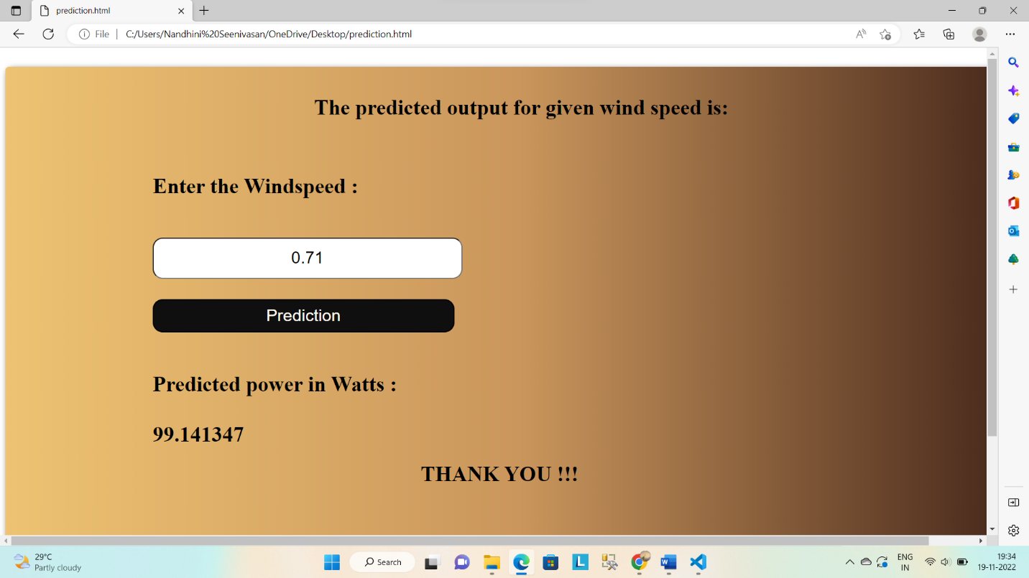

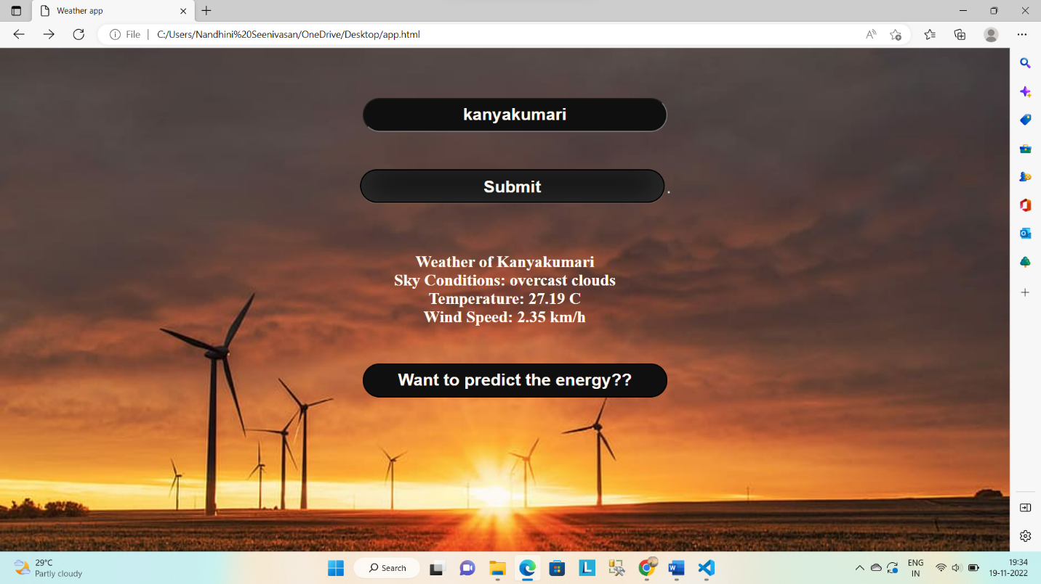

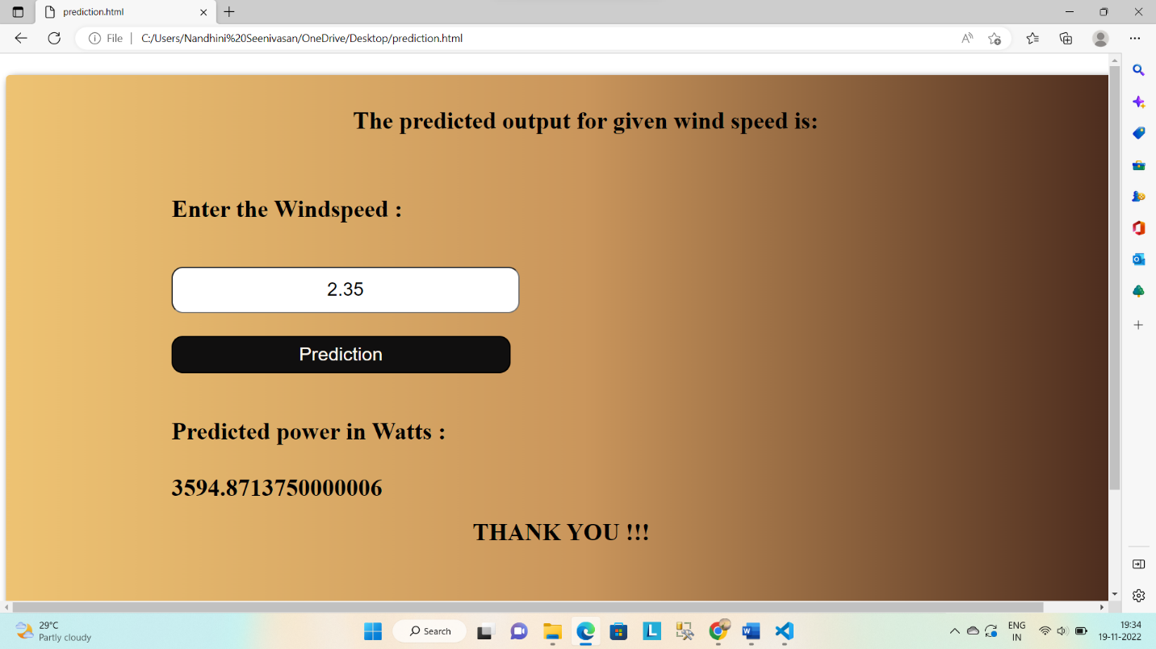

**VALIDATION METHOD:**

The power prediction by the machine learning is accurately equal to the power predicted using the formula.